2014 IDA LEWIS ETCHELLS SPRING REGATTA
MAY 16-18, 2014

IDA LEWIS YACHT CLUB
NEWPORT, RI

SAILING INSTRUCTIONS

1.0 RULES:
1.1 The regatta will be governed by the “Rules” as defined in The Racing Rules of Sailing.
1.2 The following prescriptions of US SAILING will apply: Rules 40, 61.4, 67, 76.1, and Appendix R only.
1.3 Appendix T, Section D, paragraph T5 shall apply.
1.4 The regatta is classified as an “Open Events” under Appendix “A” of the International Etchells Class rules, except that all skippers are required to be current members of the International Etchells Class Association.
1.5 Advertising is restricted to the Etchells Class rules Category A under ISAF Regulation 20. The organizing authority may require all boats to display the event sponsor’s advertising in accordance with ISAF Regulation 20.4.1.1.
1.6 The International Etchells Class Rules are changed as follows: “All competing boats shall carry a hand-held VHF radio for safety purposes, and race committee communication.”
2.0 NOTICES TO COMPETITORS:
Notices to competitors will be posted on the official notice board located at:
- The deck on the east side of the Ida Lewis Yacht Club main club house.

- Notices, including race results, amendments and protest hearing schedules, may also be available on the event website (http://www.yachtscoring.com/emenu.cfm?eID=914).

3.0 CHANGES TO SAILING INSTRUCTIONS:
Any change to the sailing instructions will be posted before 0830 on the day it is to take effect, except any change to the schedule of races will be posted by 2000 on the day before it will take effect.
- SIGNALS MADE ASHORE
4.1 Signals made ashore will be displayed at the flagpole at Ida Lewis Yacht Club.
4.2 When flag AP is displayed ashore, “one minute” is replaced with “not less than 60 minutes” in the Race Signal AP.
4.3 When flag Y is displayed ashore, competitors shall wear personal floatation devices at all times while afloat, except briefly while changing or adjusting clothing or personal equipment. This changes the preamble to Part 4.
5.0 SCHEDULE OF RACES:
5.1
Saturday, May 17, 2014
0900 Rendezvous Area Signal
1100 Warning Signal for the first race. Additional race(s) to follow.

Sunday, May 18, 2014
0900 Rendezvous Area Signal
1100 Warning Signal for the first race. Additional race(s) to follow.

5.2 A total of five races are scheduled. No more than three complete races will be run in one day.
5.3 On Sunday, May 18, 2014, no initial warning signal may be made after 1400. The warning signal for a start following one or more General Recalls may be made after 1400.
6.0 CLASS FLAG:
Codeflag ECHO will be the class flag for the starting sequence.
7.0 Racing Areas:
7.1 Rendezvous Area A will be in Rhode Island Sound approximately 1 mile south of R2 off of Brenton Point in Rhode Island Sound.
7.2 Rendezvous Area B will be in Narragansett Bay approximately ½ mile south of Halfway Rock.
8.0 COURSES:
8.1 The race course configuration will be Windward–Leeward with offset marks, and gates. (See Appendix A for diagram.)
8.2 All marks shall be left to port.
8.3 No later than the warning signal, the Race Committee Signal Boat will display on its course board:
a) The letter W followed by the number of legs to be sailed;
b) The approximate compass bearing of the first mark from the RC signal boat;
c) The approximate distance to the first mark from the RC signal boat.
9.0 MARKS:
9.1 The weather mark and gate marks will be orange inflatable marks.
9.2 New marks as described in instruction 12.1 will be yellow inflatable marks.
10.0 THE START:
10.1 Races will be started using Rule 26 with the warning signal made five (5) minutes before the starting signal.
10.2 A boat starting later than five (5) minutes after her starting signal will be scored Did Not Start without a hearing. This changes Rule A4.
10.3 The starting line will be between a staff displaying orange flag on the race committee signal boat and a staff displaying an orange flag on a port end line boat. With this line configuration, the race committee may place a mid-line indicator mark in the vicinity of and to leeward of the starting line. This mark, if present, is not part of the starting line and is for reference purposes only.
10.4 A mid-line boat may be employed. If a mid-line boat is employed, the starting line shall be between a staff displaying an orange flag on the race committee signal boat and a staff displaying an orange flag on the mid-line boat, and the staff displaying and orange flag on the mid-line boat and the staff displaying an orange flag on the port end line boat.
10.5 The race committee signal boat may be protected by a nearby inflatable limit mark, which shall rank as a starting mark. Boats shall not pass between the limit mark and the nearby signal boat when approaching the line to start.
11.0 INDIVIDUAL RECALLS:
The Race Committee will endeavor to hail each premature starter over VHF channel 72. Failure to make such an announcement or a competitor to hear such an announcement shall not be grounds for redress. This changes rule 62.1(a).
12.0 STARTING PENALTIES-I FLAG RULE:
In the event that a mid-line boat version of the starting line is used (SI10.). then Rule 30.1 I Flag Rule, is changed by adding thefollowing:” Boats subject to this rule shall sail to the pre-start side of the line around either end, or around the mid-line boat, leaving the mid-line boat to port as if it were the port end of the starting line.
13.0 CHANGE OF THE NEXT LEG OF THE COURSE
13.1 To change the next leg of the course, the Race Committee will lay a new mark (or move the finish line) and remove the original mark when practicable. When in a subsequent change a new mark is replaced, it will be replace by an original mark.
13.2 Any marks to be rounded after rounding the changed mark may be relocated to maintain the original course configuration.
14.0 THE FINISH:
The finish line will be between the staffs displaying orange flags on Race Committee vessels or between a staff displaying an orange flag on a Race Committee vessel and a nearby mark.
15.0 PENALTY SYSTEM:
15.1 A boat may take a One-Turn Penalty when she may have broken a rule of Part 2 or Rule 31 while racing. However, when she may have broken a rule of Part 2 while in the zone around a mark other than a starting mark, her penalty shall be a Two-Turn Penalty. This changes rule 44.1.
15.2 The penalty, if any, for a violation of a rule other than a rule of Part 2 or Rule 31 will be at discretion of the Protest Committee and may be other than disqualification. This changes rule 64.1(a).
16.0 TIME LIMITS:
16.1 Any race in which no boat rounds the first windward mark within 60 minutes, or in which no boat sails the course and finishes within two and one half (2.5) hours of the start shall be abandoned.
16.2 A boat not finishing within 30 minutes of the finish time of the first boat to finish a race will be score “TLE” by the Race Committee without a hearing. A “TLE” score shall be one more point than the number of boats that have finished within the time limit. This changes rules 35, A4.1, A4.2 and A5.
17.0 PROTESTS AND REQUESTS FOR REDRESS:
Protest forms are available at the Protest Committee desk at Ida Lewis YC (adjacent to the Official Notice Board). Protests shall be delivered to the Protest Committee desk within the protest time limit.
17.2 The protest time limit is one (1) hour after the Race Committee signal boat docks at the end of racing each day.
18.0 SCORING:
The Low Point scoring system shall apply, as provided in Rule A4, except that a boat’s score shall be the total of all her race scores in the regatta. This changes Rule A4.
19.0 SAFETY
19.1 Prior to the warning for the first race of each day. all boats shall check in with the Race Committee signal boat by sailing on starboard tack by the stern of the signal boat and hailing her sail number until acknowledged by the Race Committee. Boats failing to do so may be protested by the Race Committee. This changes Rule 60.2.
19.2 A boat retiring from a race and/or leaving the racing area shall notify the Race Committee by informing a Race Committee boat in person or over the designated VHF hailing channel.
20.0 HAUL OUT RESTRICTIONS:
All boats shall be afloat before 0830 on May 17, and are to remain afloat for the duration of the regatta, except with and according to terms of prior written permission of the Principal Race Officer or Protest Committee.
21.0 IDENTIFICATION – BOW NUMBERS:
The Organizing Authority will assign bow numbers to each participating boat. The numbers will be available at registration. The bow numbers shall be affixed to both the port and starboard sides in the following manner:
a) The leading edge of the forward number shall be 20” / 50 cm aft of the hull datum point (HDP);
b) The top edge of the numbers shall be 1” / 2.5 cm below the gunwale;
c) The leading edge of the aft number shall be 3” / 7.5 cm aft of the aft edge of the forward number.

See Appendix B.

22.0 SUPPORT BOATS:
22.1 Support and coach boats shall register with the Race Committee prior to the skippers’ meeting. Support boats may be given an identifying flag. The identifying flag shall be flown at all times during the regatta(s). All support boats are required to monitor VHF 72 during the regattas and respond promptly to all Race Committee or Organizing Authority directives. Additional rules pertaining to support boats may be supplied with the Sailing Instructions.
22.2 Support Boats shall remain 500 feet outside all lay lines and above/below the all marks of the course at all times while boats are racing.
23.0 PRIZES
The top three boats will be awarded prizes at the Awards Ceremony at Ida Lewis Yacht Club at 1700 on Sunday, May 18, 2014.

24.0 DISCLAIMER OF LIABILITY:
Competitors participate in the regatta entirely at their own risk. See Rule 4, Decision to Race. The Organizing Authority, sponsors and affiliated companies, will not accept any liability for material damage or personal injury or death sustained in conjunction with or prior to, during, or after the regatta. The safety of a boat and her crew is the sole and inescapable responsibility of the person in charge.

25.0 TIDES
Saturday, May 17 HIGH: 1029 and 2252
LOW 0353 and 1546
Sunday, May18 HIGH 1124 and 2347
LOW 0438 and 1636

EVENT ORGANIZERS

Ida Lewis Yacht Club Commodore
Gary H. Lash
Ida Lewis Yacht Club Race Committee Chair
John Horton
Regatta Chairman
Robbie Benjamin

APPENDIX A
Course Diagram

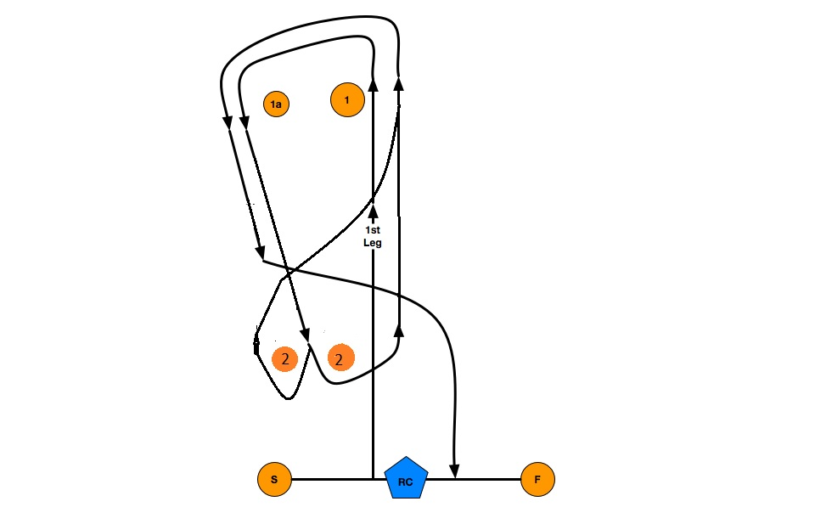

APPENDIX B

The Organizing Authority will assign bow numbers to each participating boat. The numbers will be available at registration. The bow numbers shall be affixed to both the port and starboard sides in the following manner:
- The leading edge of the forward number shall be 20” / 50 cm aft of the hull datum point (HDP);
- The top edge of the numbers shall be 1” / 2.5 cm below the gunwale;
- The leading edge of the aft number shall be 3” / 7.5 cm aft of the aft edge of the forward number.
20” / 50 cm
1” / 2.5 cm

35
3” / 7.5 cm
HDP

